**Heavy Cotton Long Sleeve Shirt**

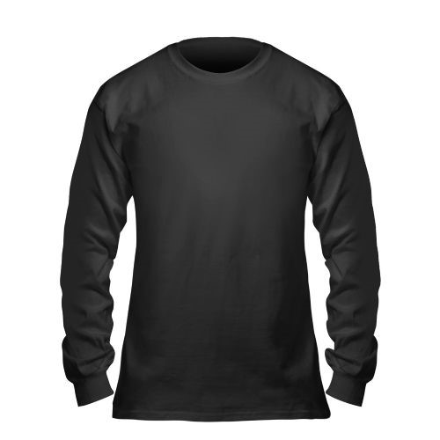**Black with Gold Logo**